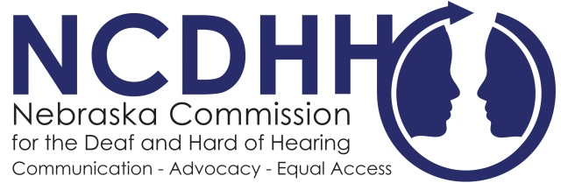
Media Contact:
Kelsey Cruz
4600 Valley Road Suite 420
Lincoln, NE 68510-4844
(402) 471-3593
Kelsey.Cruz@nebraska.gov

For Immediate Release:
August 17, 2017

Americans with Disabilities Act Task Force Established in Nebraska
The Nebraska Department of Administration Services (DAS) Personnel Division has established a new ADA Taskforce to pair with state agencies and organizations in an effort to ensure Nebraska agencies are in compliance with up to date ADA policies and procedures to all citizens.
A legislative agenda item from the NCDHH Full Board is now becoming closer to reality with the establishment of this oversight Task Force.
“The Commission for the Deaf and Hard of Hearing is looking forward to working with the new state ADA Coordinator,” NCDHH Board Chairman Margie Propp said. “There is much work ahead to ensure all Nebraskans who are Deaf, Deaf-Blind or Hard of Hearing have accessibility in all areas of communication and will not face discrimination in all facets of life.”
This Task Force is comprised of individuals and representatives from NCDHH, Nebraska Commission for the Blind and Visually Impaired (NCBVI), Nebraska Office of the Chief Information Officer (OCIO), Disability Rights Nebraska, Nebraska Equal Opportunity Commission, 309 Task Force and DAS personnel. The primary role of the ADA Task Force will be assisting State Agencies to ensure that State programs, activities and services are accessible to all citizens under the Title II of the Americans with Disabilities Act. This task force will also provide training, serving as a resource for state agencies and to mediate any citizen concerns.
Education Advocate and NCDHH Board Member Dr. Pete Seiler said this advancement continues Nebraska in the right direction for equality.

“The revived position of ADA Coordinator comes at a time when disabled workers, especially Deaf, Deaf-Blind and Hard of Hearing individuals, face discrimination in both hiring practices and effective communication. This is a step in the right direction.”
In the upcoming months the task force will be seeking additional applications for five board members from the public. More information will be available soon on the application process.

#

